**PJ 13 Report My Name: _Yaowei Lei___**

**A. The following is my Python source program:**

**// Please copy your source program into here from your Visual Studio IDE.**

**// Your code here must be in color. You must not show screen prints here.**

#------------------------------------------------------------------------------------------------------------.

# Author: Yaowei Lei

# Date: 12/16/2021

# Purpose: CS119-PJ13: Student Report System – store the information of some students and print out the report.

#------------------------------------------------------------------------------------------------------------.

class Student (object ):

# constructor with 5 attributes

def __init__(self, studentID, lastName, firstName, GPA, phoneNumber) :

self.studentID = studentID

self.lastName = lastName

self.firstName = firstName

self.GPA = GPA

self.phonrNumber = phoneNumber

# 5 accessors

def getStudentID (self) :

return self.studentID

def getLastName (self) :

return self.lastName

def getFirstName (self) :

return self.firstName

def getGPA (self) :

return self.GPA

# 5 mutators

def setPhoneNumber (self, phoneNumber) :

self.phonrNumber = phonrNumber

def setStudentID (self, studentI):

self.studentID = studentI

def setLastName (self, lastName) :

self.lastName = lastName

def setFirstName (self, firstName) :

self.firstName = firstName

def setGPA (self, GPA) :

self.GPA = GPA

def setPhoneNumber (self, phonrNumber) :

self.phonrNumber = phonrNumber

def __str__ (self) :

return "[%s, \'%s\', \'%s\', \'%s\', \'%s\']" % (self.studentID, self.lastName, self.firstName, self.GPA, self.phonrNumber)

def printEntered(self) :

print("You just entered the following student record: ")

print("Student ID:", self.studentID)

print("Last Name:", self.lastName)

print("First Name:", self.firstName)

print("GPA:", self.GPA)

print("Phone Number:", self.phonrNumber)

def printReport (studentList, countStudent, totalGpa, averageGpa) :

print("========= CURRENT REPORT OF ALL STUDENTS ===============")

print("Current Student Count =", countStudent)

print("Total GPA of all students = %.1f" % totalGpa)

print("Average GPA of all students = %.1f" % averageGpa)

print("All student records are as follows:")

for s in studentList :

print(s)

print("========= END OF REPORT =================================")

print( )

# Beginning of MAIN PROGRAM ============================================.

n = 1 # line number for each separator line

print ("Welcome to the Student Report System of Yaowei Lei!")

print (n,"============================================================"); n+=1;

countStudents = 0 # count the total number of students being constructed

totalGpa = 0.0 # total GPA summation of all students

averageGpa = 0.0 # average GPA of all students

slist = [ ] # empty list to store all the student records

id = input("Please enter first student ID: ")

lName = input("Please enter last name: ")

fName = input("Please enter first name: ")

gpa = input("Please enter GPA: ")

pNumber = input("Please enter phone number: ")

student = Student(id, lName, fName, gpa, pNumber)

student.printEntered()

slist.append(student)

countStudents += 1

totalGpa += float(student.getGPA())

averageGpa = totalGpa / countStudents

printReport (slist, countStudents, totalGpa, averageGpa)

while True :

print (n,"============================================================"); n+=1;

id = input("Please enter next student ID: ")

if id == "0" :

break

lName = input("Please enter last name: ")

fName = input("Please enter first name: ")

gpa = input("Please enter GPA: ")

pNumber = input("Please enter phone number: ")

student = Student(id, lName, fName, gpa, pNumber)

student.printEntered()

slist.append(student)

countStudents += 1

totalGpa += float(student.getGPA())

averageGpa = totalGpa / countStudents

printReport (slist, countStudents, totalGpa, averageGpa)

print (n,"============================================================"); n+=1;

print("Thank you for using the Student Report System of Yaowei Lei!")

print (n,"============================================================"); n+=1;

# End of MAIN PROGRAM ============================================.

**B. The following is the console output of my 3 test runs:**

**// One way to copy the console output is to press Ctrl+Alt+PrtScn.**

**// Another way to copy is to use the snipping tool. To paste the image is to press Ctrl+v.**

**// The console display must not be too wide, otherwise it will be too hard to read once pasted.**

**// Please make sure your console is long enough to show all your output lines to be captured.**

**// Please copy your console output and paste into here:**

**Test Case #1:**

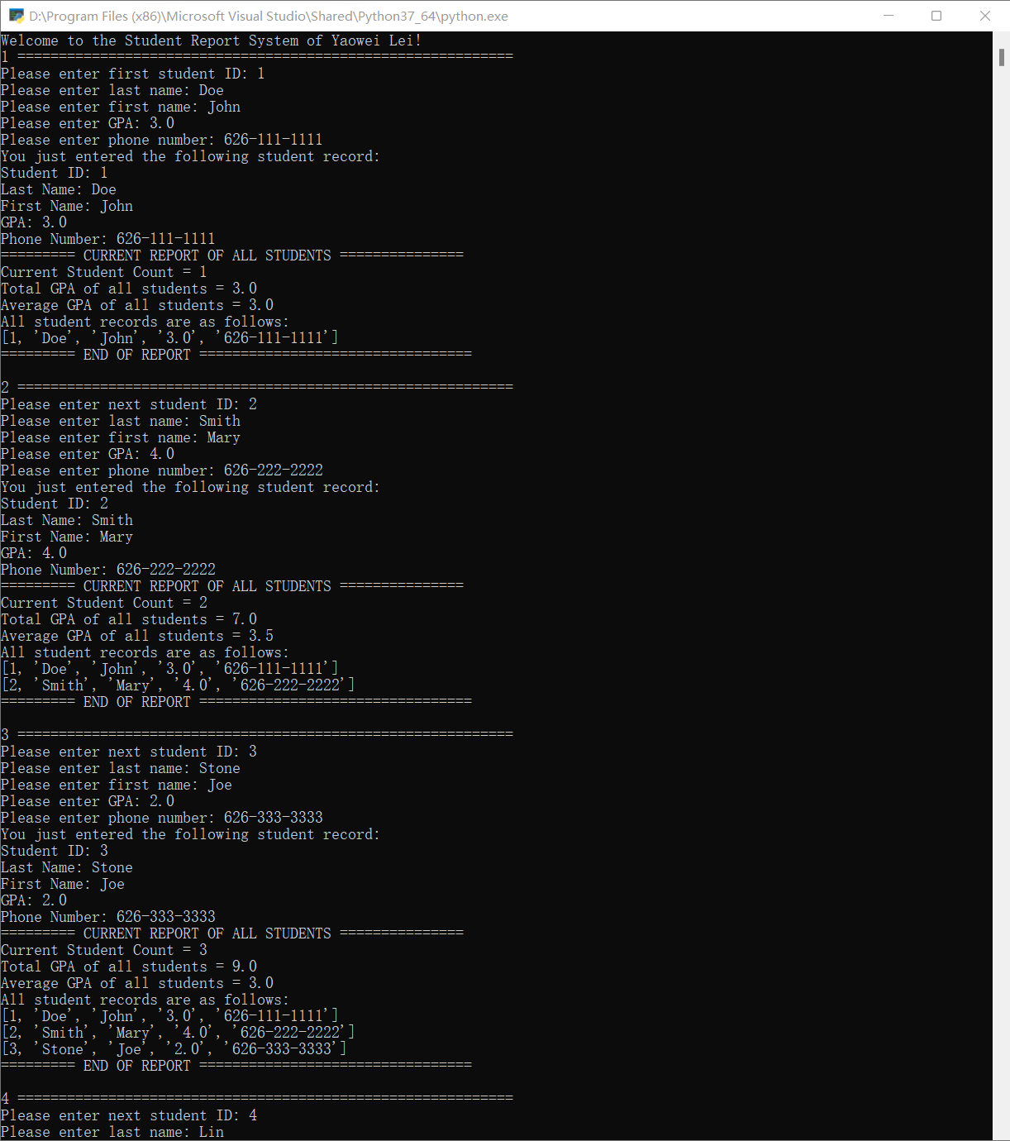

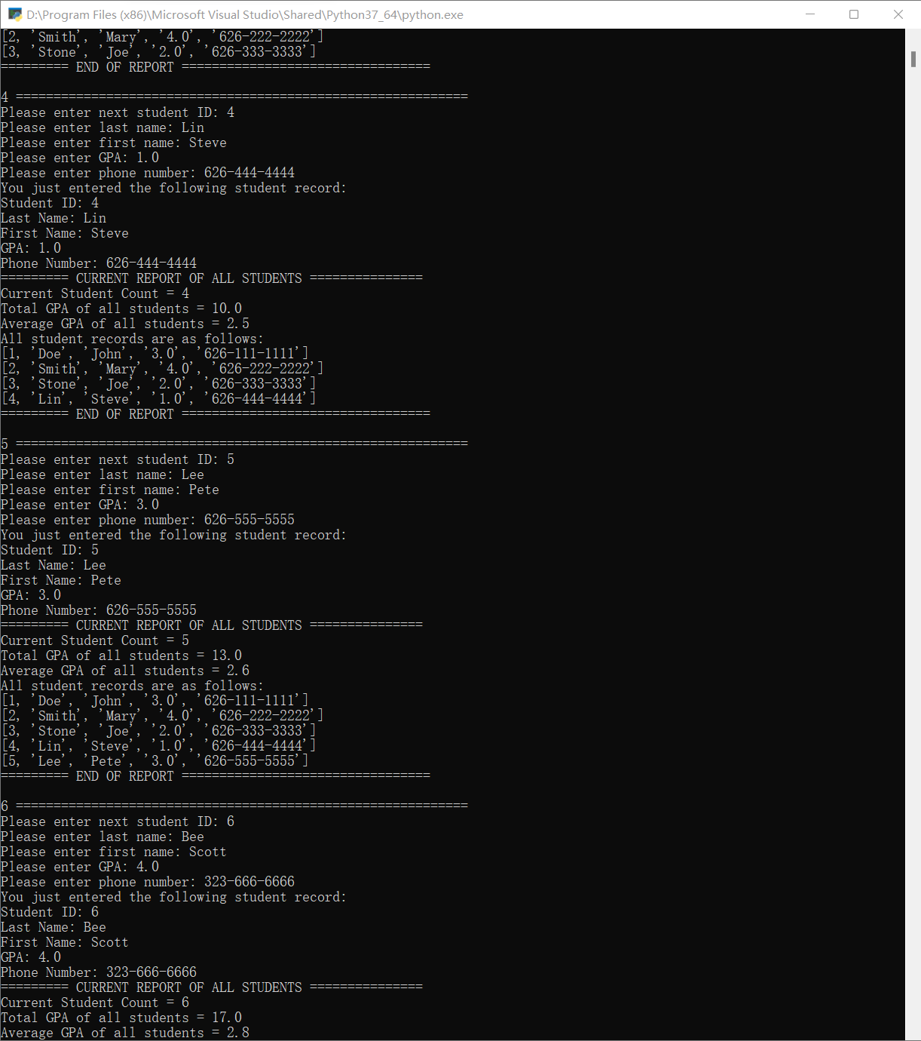

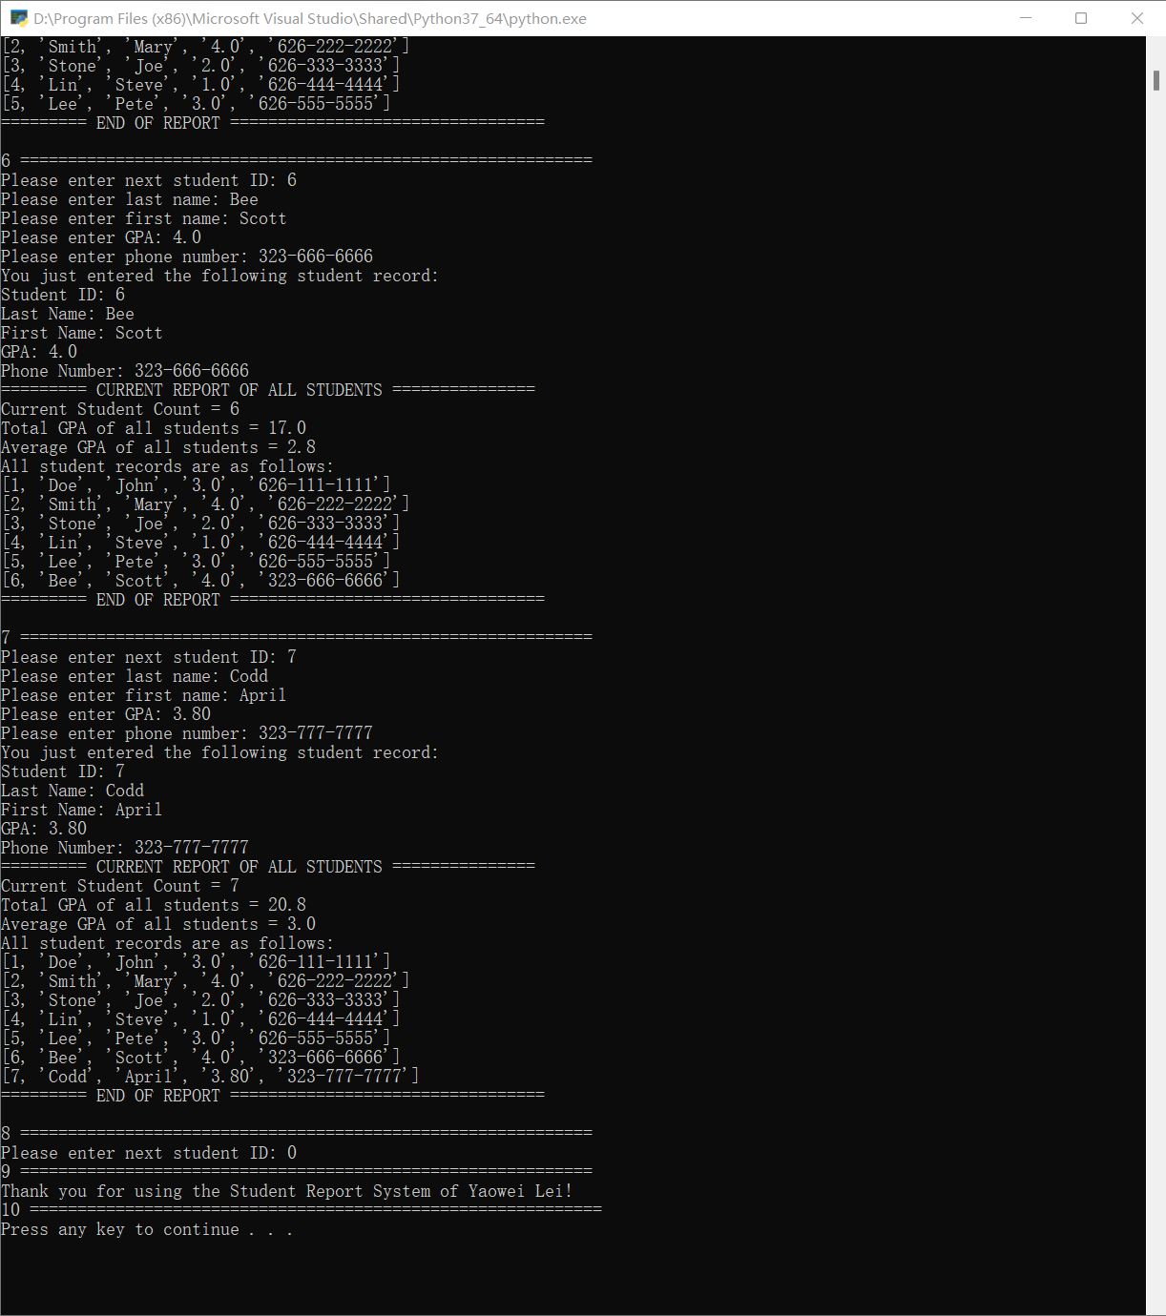

**Test Case #2:**

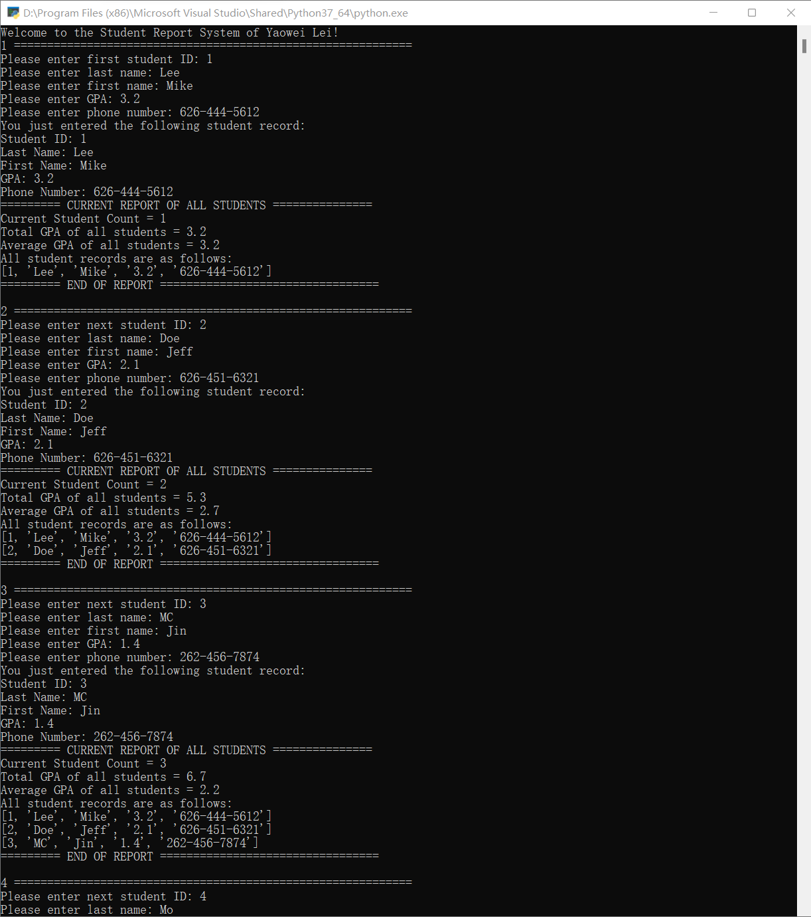

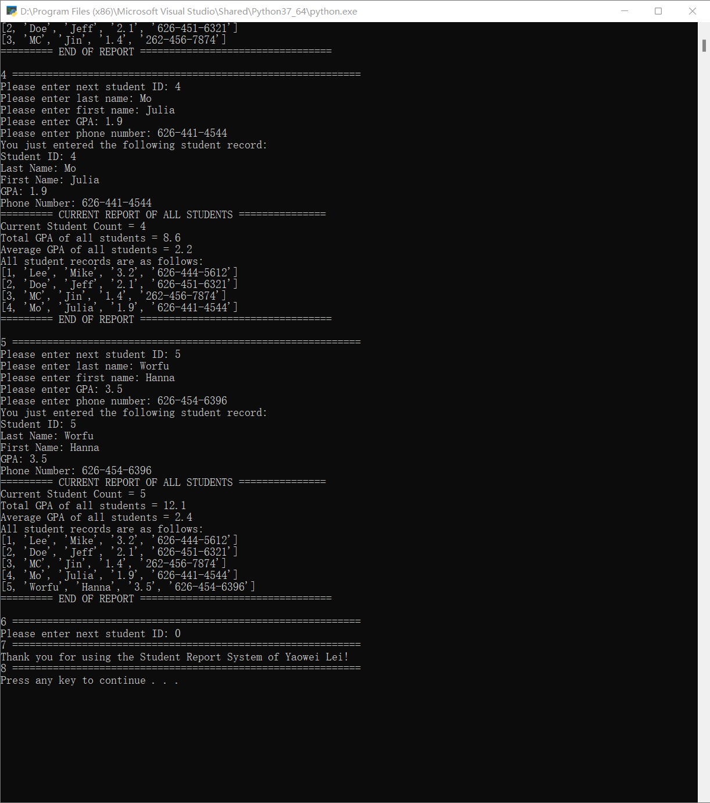

**Test Case #3:**

